Reporter Toolkit
Who are VPC and CVI?
VPC and CVI are the nation’s largest non-partisan, non-profit organizations working to ensure the New American Majority (NAM) - people of color, young people, and unmarried women - participate in democracy equal to their presence in society. By utilizing direct mail deployed on a massive scale, plus cutting-edge digital outreach, VPC connects with millions of voters each year, helping to build the foundation for a more representative democracy.

Since 2003, VPC and CVI have helped more than 5.8 million people - and counting - register to vote.

There’s a lot of misinformation and disinformation about the activities of third-party civic engagement groups like ours, so here are some basic facts:

Do VPC and CVI mailers confuse voters who are already registered?
No! If an individual receives our mailer and is already registered to vote, they can simply discard our mailer and know they are already registered to vote. We make this clear in the letter that voters receive from our organizations.

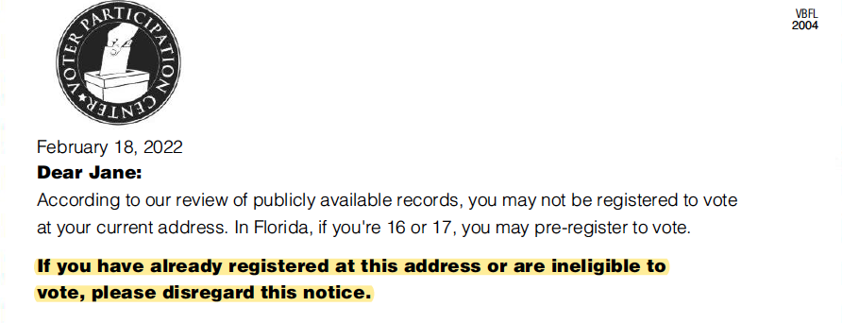
What if a voter is unsure if they are registered?
As stated in our letters, voters can visit their state Secretary of State website to check their registration status.

What if a voter receives a form with incorrect information filled in?
VPC and CVI make registration easier by pre-filling names and addresses on voter forms, wherever the practice is allowed. . In rare cases when the pre-filled information is incorrect, voters can simply cross out those sections and write in the correct information. Here’s what our letters clearly state:

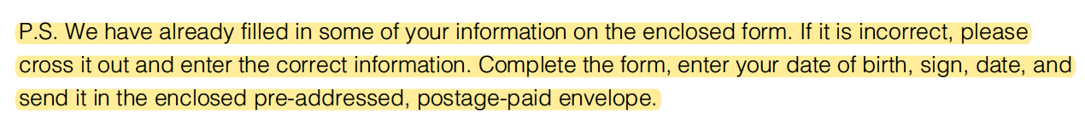

Why is the work of VPC and CVI important?
VPC and CVI are bringing democracy straight to American’s doorsteps - or smartphones - and making it as simple as possible to vote. Individuals can simply fill out the same voter registration form that is provided by the state, sign it, and mail in their voter registration application.

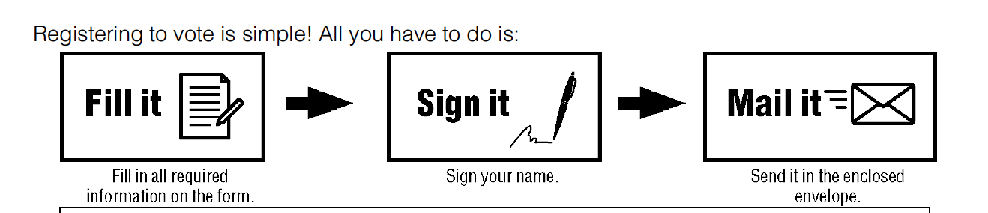

If election officials are already doing voter outreach, what makes the work of VPC and CVI necessary?
VPC and CVI specifically work to engage and turn out the New American Majority - people of color, young people, and unmarried women. While the NAM is 150-million strong across the nation, representing 64 percent of all Americans who can vote, we know that they register and vote at rates lower than their actual numbers.

To be clear: many of these individuals would simply not be reached were it not for the work of VPC and CVI. We do the hard work that state and county election officials rarely do, in finding people who are not registered to vote and bringing them into the system.

Are these mailers a legitimate way for Americans to register to vote?
Yes, VPC and CVI use the very same voter registration forms used by county election officials. In fact, we provide sample letters to state election officials months before the mailers go out.

Do VPC and CVI use incorrect data?
Unfortunately, no state makes available a list of individuals who are unregistered or ineligible. As a result, VPC and CVI must use commercially available residential databases and match them to the state’s voter file to determine who is unregistered and otherwise eligible. This process allows us to reach out to individuals who might be otherwise overlooked.

As the sender of millions of pieces of mail in this election alone, VPC and CVI take our mailing list process seriously and we’re constantly refining this process to ensure accuracy. With the help of industry-leading vendors, we use the best technology available to ensure that our mail recipients are both eligible to vote and unregistered at their current address. We also check against a database of common pet names and fictitious names with approximately 3,000 entries.

Additional questions? Reach out to media@voterparticipation.org and someone will promptly get back to you.

